Project Plan

1. Work Breakdown Structure – All the necessary roles and function would be briefed below.

Essential roles –

* + 1. Developers – developers would be coming up with ways on how to deploy Member registration application as a containerized solution. They will also be working on automation of the deployment process along with the application administrator.
    2. Server Administrator – Infrastructure like servers, user accounts, network, virtual ip’s and secured network are all important and required as soon as the project starts. A dedicated server administrator would be ideal for this.
    3. Application Administrator- Application administrator would be required to setup the required software on all the machines and let the developers start to deploy their application and test.

Application administrator will also be working on developing an automated solution for the deployment process. Ask will also be to create another environment for production after the deployment process is in place.

* + 1. System Analyst- An analyst will help test out the application functionality and report and bugs encountered during testing. Documentation of the process and creating required visual diagrams using CASE will be done and sent to the required audience to make sure there is on issue with understanding the requirements.
    2. Project Manager – A project Manager will help and see if the project is going as planned and help with any issues the team may encounter.

1. Project Monitoring and Control Plan –

As mentioned above the servers and infrastructure will be the critical component to start this project. After the planning stage, the infrastructure setup will be the first step to start. The deadline for this would be two weeks and the project manager will be checking on the status of the how the tasks are coming along every couple of days.

After the second week, application administrator will start to setup the required software and configure the deployment tool. The priority being the installing the software so that the developers can start to containerize the member registration application. Following that will be the installation and the setup of the deployment tool. The estimated timeline for this would be another two week. System analyst will be working with the first two groups and make sure the requirements are understood correctly and no time is wasted in redoing the setup. The required requirement and the design and the documentation explain the dataflow and the application design is completed in during the first week.

The developers will start the development at the start of week three and start containerizing the application. The first iteration of testing will start at the end of week five with manually deploying the application to a testing environment. The automation of deploying would be ideal if it starts on week six. A developer and an application administration would start testing the deployment process out with the same application being tested in a parallel method.

Week seven and eight would be to wrap up testing and deploy to production and fix any minor bugs or issues that may have encountered during the project. Reports can be generated on the amount of time the application administrator will be spending on deploying the app and follow up actions could be taken to either convert the rest of the applications to follow this process or fall back to the alternate way of deploying applications.

There are two critical path here, one is to get the infrastructure and the tool setup in place in the first two to three weeks and then the second would be to containerize, automate and deploy the application in the next following weeks.

1. Timeline –

The estimated timeline for the project is going to be two months. The following charts show the timeline as a visual representation based on the system development life cycle.

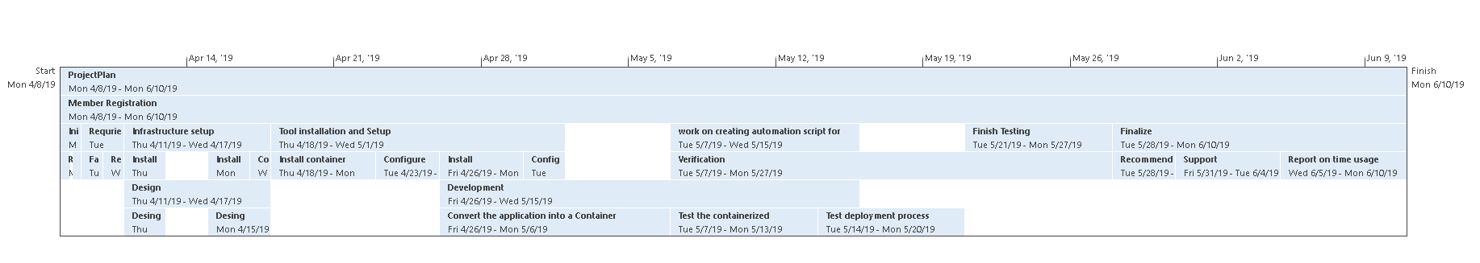

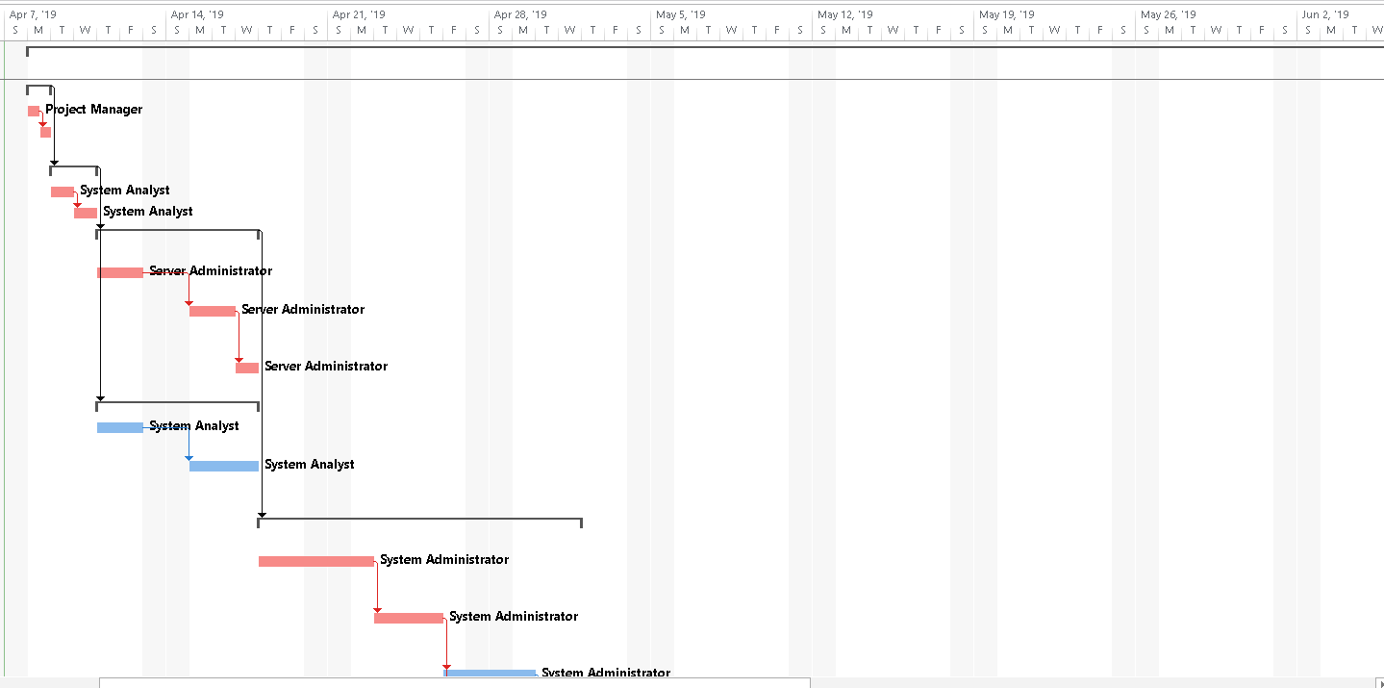

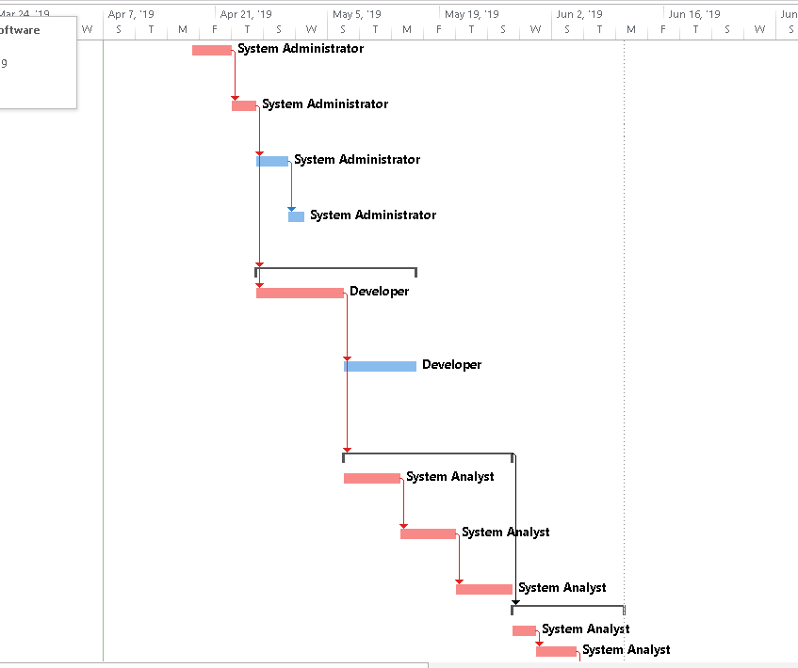

|  |  |  |  |  |  |  |
| --- | --- | --- | --- | --- | --- | --- |
| Task Mode | Task Name | Duration | Start | Finish | Predecessors | Resource Names |
| **Auto Scheduled** | **Member Registration** | **46 days** | **Mon 4/8/19** | **Mon 6/10/19** |  |  |
| **Auto Scheduled** | **Initial Planning** | **1 day** | **Mon 4/8/19** | **Mon 4/8/19** |  |  |
| Auto Scheduled | Review project | 0.5 days | Mon 4/8/19 | Mon 4/8/19 |  | Project Manager |
| Auto Scheduled | Create Schedule | 0.5 days | Mon 4/8/19 | Mon 4/8/19 | 3 |  |
| **Auto Scheduled** | **Requirements** | **2 days** | **Tue 4/9/19** | **Wed 4/10/19** | **2** |  |
| Auto Scheduled | Fact finding | 1 day | Tue 4/9/19 | Tue 4/9/19 |  | System Analyst |
| Auto Scheduled | Review System | 1 day | Wed 4/10/19 | Wed 4/10/19 | 6 | System Analyst |
| **Auto Scheduled** | **Infrastructure setup** | **5 days** | **Thu 4/11/19** | **Wed 4/17/19** | **5** |  |
| Auto Scheduled | Install new servers | 2 days | Thu 4/11/19 | Fri 4/12/19 |  | Server Administrator |
| Auto Scheduled | Install operating system | 2 days | Mon 4/15/19 | Tue 4/16/19 | 9 | Server Administrator |
| Auto Scheduled | Connect with network | 1 day | Wed 4/17/19 | Wed 4/17/19 | 10 | Server Administrator |
| **Auto Scheduled** | **Design** | **5 days** | **Thu 4/11/19** | **Wed 4/17/19** | **5** |  |
| Auto Scheduled | Design Data Flow | 2 days | Thu 4/11/19 | Fri 4/12/19 |  | System Analyst |
| Auto Scheduled | Design Deployment Process | 3 days | Mon 4/15/19 | Wed 4/17/19 | 13 | System Analyst |
| **Auto Scheduled** | **Tool installation and Setup** | **10 days** | **Thu 4/18/19** | **Wed 5/1/19** | **8** |  |
| Auto Scheduled | Install container software | 3 days | Thu 4/18/19 | Mon 4/22/19 |  | System Administrator |
| Auto Scheduled | Configure container software | 3 days | Tue 4/23/19 | Thu 4/25/19 | 16 | System Administrator |
| Auto Scheduled | Install deployment tool | 2 days | Fri 4/26/19 | Mon 4/29/19 | 17 | System Administrator |
| Auto Scheduled | Configure deployment tool | 2 days | Tue 4/30/19 | Wed 5/1/19 | 18 | System Administrator |
| **Auto Scheduled** | **Development** | **14 days** | **Fri 4/26/19** | **Wed 5/15/19** | **17** |  |
| Auto Scheduled | Convert the application into a Container | 7 days | Fri 4/26/19 | Mon 5/6/19 | 17 | Developer |
| Auto Scheduled | work on creating automation script for deployment | 7 days | Tue 5/7/19 | Wed 5/15/19 | 21 | Developer |
| **Auto Scheduled** | **Verification** | **15 days** | **Tue 5/7/19** | **Mon 5/27/19** | **21** |  |
| Auto Scheduled | Test the containerized application | 5 days | Tue 5/7/19 | Mon 5/13/19 |  | System Analyst |
| Auto Scheduled | Test deployment process | 5 days | Tue 5/14/19 | Mon 5/20/19 | 24 | System Analyst |
| Auto Scheduled | Finish Testing | 5 days | Tue 5/21/19 | Mon 5/27/19 | 25 | System Analyst |
| **Auto Scheduled** | **Finalize** | **10 days** | **Tue 5/28/19** | **Mon 6/10/19** | **23** |  |
| Auto Scheduled | Recommendations | 3 days | Tue 5/28/19 | Thu 5/30/19 |  | System Analyst |
| Auto Scheduled | Support documentation | 3 days | Fri 5/31/19 | Tue 6/4/19 | 28 | System Analyst |
| Auto Scheduled | Report on time usage | 4 days | Wed 6/5/19 | Mon 6/10/19 | 29 | System Analyst |